Patient Questionnaire
Patient Name:____________________________________________________ Date _______________
Age: ______ DOB: ______________ Sex: □ Male □ Female □ R- Handed □ L- Handed
Who Referred You? (Full Name )_______________________________ Phone:__________________________________
Address: ___________________________________________________________________________________________
Where is your Pain?__________________________________________________________________________________
Why do you need to see a Pain Specialist?
____________________________________________________________________________________________________________________________________________________________________________________________________

Please Mark an “X” on the figure below where your pain starts and show where it goes using an arrow: -

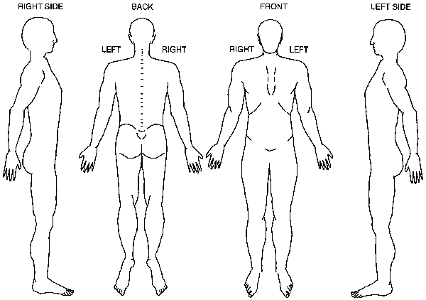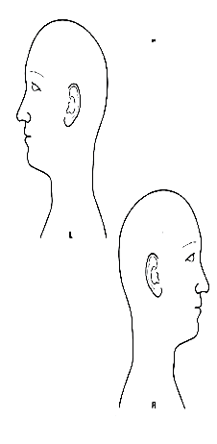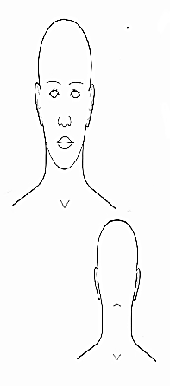

How and when did your pain begin? ___________(Month/Year) Describe the circumstances around the on set of
□ Work Accident | □ Following Surgery/illness | Your Pain:
□ Home Accident | □ Other Accident | _______________________________
□ Auto Accident | □ Unknown | _______________________________
□ Other______________________________ |  | _______________________________

Circle the number that best describes how severe your pain is.
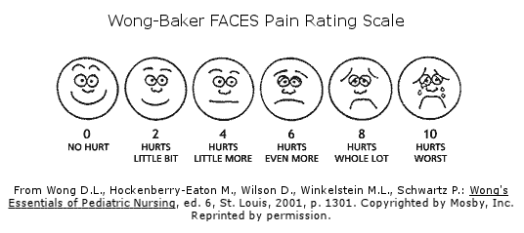

How often does the pain occur?
□ Continuously □ Several times per day □ Intermittent □ Occasionally □ less than daily

How do the following factors affect your pain? (Please √ )
 | Better | Worse | No Effect |  | Better | Worse | No Effect
1. Heat | □ | □ | □ | 6. Climate | □ | □ | □
2. Cold | □ | □ | □ | 7. Fatigue | □ | □ | □
3. Lying Down | □ | □ | □ | 8. Coughing | □ | □ | □
4. Sitting | □ | □ | □ | 9. Massage | □ | □ | □
5. Walking | □ | □ | □ | 10. Alcohol | □ | □ | □

What Makes your pain WORSE? (√ )
□ Bending | □ Coughing | □ Standing a long Time
□ Lifting | □ Sneezing | □ Sitting a Long Time
□ Defecation | □ Sexual Intercourse | □ Other: (Please Describe)______________________________________________
_________________________________________________________________________________________________________
In What Position do you sleep? □ Back □ Side □ Stomach
Are there any other symptoms/problems associated with pain?
□ Difficulty Sleeping | □ Intercourse is painful | □ Feeling "blue" all the time
□ Difficulty with Intercourse | □ Other please describe | ______________________________________________

Yes | No
□ | □ | Do you have the Urge to move your legs at night or at rest?
□ | □ | Do you have the numbness in your legs or feet or discomfort?
□ | □ | Do your Symptoms worsen when you are lying down or resting?
□ | □ | Do your symptoms worsen at night?
□ | □ | Do you get relief with movement with walking or stretching?
 |  | How many times do you wake up in the middle of the night? _________
 |  | What time do you go to bed and fall asleep? ______________
 |  | What time do you wake up to do you morning routine______________
Treatment History
If you do not have back or low back pain, skip this section and go to “past medical history” section)
1. Which of the following caregivers have you visited prior to your arrival here? (Please give names)
________________________________________________________________________________________
□ Family physicians (includes general practitioners, Internists, gynecologists, etc)
□ Sports Medicine | □ Orthopedic Surgeon | □ Neurologist | □ Rheumatologist
□ Occupational Medicine | □ Anesthesiologist | □ Rehabilitation Medicine
□ Other Pain Management _____________________________________________________
□ Osteopathic | □ Chiropractor | □ Acupuncturist
□ Alternative Medicine | □ Bio feed back
2. Which of the following test(s) have you undergone prior to your arrival today?
□ x-Rays | □ CAT Scan | □ MRI Scan | □ EMG test
□ Discogram | □ Neural Block | □ Myelogram
3. Have you had any of the following interventions done for your neck or low back pain?
□ TENS/ nerve stimulator | □ Ultrasound | □ Heat | □ Cold |  | □ Cryotherapy
If so How many Times? | □ 1 | □ 2 | □ 3 |  | □ 4 or More
□ Trigger Point Injections
If so How many Times? | □ 1 | □ 2 | □ 3 |  | □ 4 or More
□ Facet | □ Sacroiliac | □ Other Joint injections ___________________
□ Discography

5. Have you ever had any of the following surgical interventions (for neck and back pain)?
□ Discectomy done in (yr) _____ |  | □ Laminectomy done in (yr)
□ Temporary Spinal Cord Stimulator done in (yr)__________
□ Permanent Spinal Cord Stimulator done in (yr)___________
□ Lumbar or Sacral Cage/Hardware done in (yr) ____________
□ Bed rest | □ Lumbar Traction |  | □ Exercise | □ Physical Therapy
□ Manipulations | □ Mobilization |  | □ Mediations | □ Prolotherapy
□ Therapeutic Injections of any kind |  |  | □ Counseling | □ Hypnosis | □Loss of work

Past Medical History
Please list all, If any DRUG ALLERGIES and their REACTIONS:
____________________________________________________________________________________________________________________________________________________________________________________________________________________________________________________________________________________________________________________________________

Do you take any of the following?
□ Aspirin □ Coumadin □ Plavix □ Heparin □ Pletal □ Lovenox □ Ticlid
Previous Pain Medications: _____________________________________________________________________________________
___________________________________________________________________________________________________________
□ Use Illegal drugs
Please list all MEDICATIONS:
CURRENT MEDICATIONS DOSAGE HOW OFTEN
1
2
3
4
5
6
7
Please List all MEDICAL PROBLEMS:
__________________________________________________________________________________________________________
__________________________________________________________________________________________________________
__________________________________________________________________________________________________________
List all Surgeries and their DATES:
__________________________________________________________________________________________________________
__________________________________________________________________________________________________________
__________________________________________________________________________________________________________

SOCIAL HISTORY
Any use to Tobacco (type and for how long)? _____________________________________________________________________
Any use of Alcohol (type and for how long)? ______________________________________________________________________
Any use of Recreational Drugs (type and for how long)? ____________________________________________________________

RACE: □ American Indian/Alaska Native □ Asian □ Native Hawaiian □ Other Pacific Islander □ White □ African American
□ More than one □ Refuse to Report
ETHNICITY: □ Hispanic/ Latino □ Non Hispanic Latino □ Refuse to Report LANGUAGE: ________________________

What type of work do you do? _________________________________________________________________________________

Education: □ Grade school □ High School □ College □ Post Graduate □ Vocational Training

Marital Status: □ Single □ Married □ Divorced □ Widowed

Family History
Mother: | □ Living | □ Deceased Age ___________ | □ Health Issues: _______________
Father: | □ Living | □ Deceased Age ___________ | □ Health Issues: _______________
Brother(s) # _______ | □ Living | □ Deceased Age ___________ | □ Health Issues: _______________
Sister(s) #_________ | □ Living | □ Deceased Age ___________ | □ Health Issues: _______________

REVIEW OF SYMPTOMS

If you currently have any of the following Symptoms, please place a (√) on the one that applies:
"Constitutional" | □ Fever | □ Weight Loss | □ Fatigue | □ No Problems
Eye Problems | □ Blurred Vision | □ Double Vision | □ Loss of Vision
 | □ Eye Pain | □ Eye Redness | □ Eye Dryness | □ No Problems
Ear/Nose/Throat | □ Trouble Hearing | □ Ringing in Ears | □ Dizziness(vertigo)
 | □ Loss of Balance | □ Ear Pain | □ Ear Discharge | □ No Problems
Cardiovascular | □ Chest Pain | □ Irregular Heart Beat | □ High Blood Pressure
 | □ Limb Pain on Walking |  | □ Fainting | □ No Problems
Respiratory | □ Indigestion | □ Heart Burn | □ Abdominal Pain
 | □ Nausea | □ Vomiting | □ Regurgitation
 | □ Diarrhea | □ Constipation | □ Bloody stools | □ No Problems
Genitourinary | □ Incontinence | □ Pain on Urination | □ Blood in Urine | □ No Problems
Musculoskeletal | □ Muscle Pain | □ Muscle Cramp | □ Loss of Muscle Bulk
 | □ Neck Pain | □ Back pain | □ Joint Pain
 | □ Joint Stiffness | □ Joint Swelling |  | □ No Problems
Skin & Breast | □ Numbness | □ Tingling | □ Discoloration
 | □ Hair Loss | □ Nail Change | □ Sweating Change | □ No Problems
Neurological | □ Headache | □ Face Pain | □ Face Numbness
 | □ Black Outs | □ Weakness | □ Tremors
 | □ Seizures | □ Trouble with Memory | □ Trouble Concentrating | □ No Problems
Psychiatric | □ Hallucinations | □ Feeling Depressed | □ Trouble Sleeping
 | □ Suicidal Thoughts | □ Inappropriate Crying | □ Inappropriate Laughing | □ No Problems
Hematological/ Lymphatic | □ Abnormal Bleeding | □ Anemia | □ lumps or Swelling | □ No Problems
Allergic/Immunologic | □ Skin Rash | □ Joint Pain | □ Dry Eyes7/or Dry Mouth | □ No Problems
Endocrine | □ Excessive Rash | □ Heat or Cold Intolerance | □ Excessive Urination | □ No Problems

__________________________________________ □ Patient □ Parent/Guardian □ Representative
Signature

Please list all Physicians that you are with. (GP, obgyn, Chiro, etc)

Physician Name: _______________________________________ Specialty ____________________________________

Address _________________________________________________City _________________________ State/Zip

Phone _____________________________________ Fax __________________________

Physician Name: _______________________________________ Specialty ____________________________________

Address _________________________________________________City _________________________ State/Zip

Phone _____________________________________ Fax __________________________

Physician Name: _______________________________________ Specialty ____________________________________

Address _________________________________________________City _________________________ State/Zip

Phone _____________________________________ Fax __________________________

Physician Name: _______________________________________ Specialty ____________________________________

Address _________________________________________________City _________________________ State/Zip

Phone _____________________________________ Fax __________________________

Physician Name: _______________________________________ Specialty ____________________________________

Address _________________________________________________City _________________________ State/Zip

Phone _____________________________________ Fax __________________________

